Sustainable Energy Marketplace and Societal Readiness

Hyungjin Kim
Pennsylvania State University
e-mail: hzk80@psu.edu

Saya Lee
Pennsylvania State University
e-mail: sayalee@psu.edu

Nonna Sorokina*
Pennsylvania State University
Phone: 570-963-2662
e-mail: sorokina@psu.edu

Darshana Sunoj
Pennsylvania State University
e-mail: darshanasunoj@gmail.com

This Draft: August 30, 2024

Corresponding author:
Nonna Sorokina, email sorokina@psu.edu, ph. 570-963-2662

The research project is generously funded by the Nuclear Energy University Program (NEUP), U.S. Department of Energy grant number is DE-NE0009381, Penn State Institute for Computational and Data Sciences (RRID:SCR_025154) and Penn State University Center for Applications of Artificial Intelligence and Machine Learning to Industry Core Facility (RRID:SCR_022867). Comments and suggestions received from the Frontier/PIMA consortium team at Penn State University were invaluable in shaping up this research. We are especially thankful to Gretta Kellogg for the continued support and to Sola Talabi for helpful discussions of SRL framework. Excellent research assistantship was provided by Jainil Kakka and Praneeth Sunkavalli.

Sustainable Energy Marketplace and Societal Readiness

Abstract
This paper develops a comprehensive green energy investment model that examines the intricate relationship between societal acceptance, financial returns, and investment decisions in the context of green energy projects. The model is specifically applied to the aftermath of the Fukushima nuclear disaster, a pivotal event that reshaped public perceptions and policy directions regarding energy sources. By integrating societal acceptance as a key variable, the model accounts for the influence of public opinion on investment flows and expected returns in the green energy sector. The study utilizes empirical data to validate the model, demonstrating how societal acceptance significantly impacts both the risk and profitability of green energy investments. The findings underscore the importance of aligning investment strategies with societal values, particularly in the wake of events that shift public attitudes towards energy sources. This research contributes to the broader understanding of sustainable energy investments, offering insights for policymakers and investors on how to navigate the complexities of public sentiment in the transition to green energy.

The only thing we have to fear is fear itself—nameless, unreasoning, unjustified terror.”
—Franklin D. Roosevelt

Introduction

The transition towards sustainable energy sources is a critical global objective, driven by the need to mitigate climate change and reduce dependency on fossil fuels. Within this context, investment in green energy—encompassing renewable energy technologies like wind, solar, and hydroelectric power—has gained significant attention from policymakers, investors, and consumers alike. The financial viability of green energy projects, however, hinges not only on traditional market factors such as costs and returns but also on the evolving attitudes of investors and consumers towards these technologies. This paper seeks to explore the intricate relationships between societal acceptance, investor behavior, and investment in green energy, using a theoretical model that is empirically tested through a reduced-form approach.
Green energy is often perceived as being synonymous with renewable sources like solar and wind, which are praised for their sustainability and minimal environmental impact. However, nuclear energy, despite being a carbon-free and highly reliable power source, is frequently excluded from the green energy narrative. This exclusion stems from concerns about radioactive waste, potential accidents, and public fear, despite its capacity to produce large amounts of energy with a small environmental footprint. Ironically, nuclear energy is arguably one of the most viable solutions for meeting large-scale energy demands without contributing to greenhouse gas emissions, making its exclusion from the green energy conversation both a missed opportunity and a point of contention. In this paper, we focus on nuclear energy to test our propositions regarding sustainable energy investments and thus societal readiness becomes a cornerstone of the investors’ decisions.
Traditional asset pricing models, such as the Capital Asset Pricing Model (CAPM) developed by Sharpe (1964) and the Intertemporal Capital Asset Pricing Model (ICAPM) proposed by Merton (1973), primarily focus on pecuniary returns and abstract from the nonpecuniary utility that investors may derive from holding certain assets. These models assume homogeneity in investor preferences and ignore the potential influence of non-financial factors, such as environmental, social, and governance (ESG) concerns, on investment decisions. However, a growing body of research has begun to challenge these assumptions, incorporating factors such as disagreement over payoffs and investor tastes for certain types of assets, particularly those aligned with ESG criteria.
One of the most notable contributions to this field is the work by Pastor, Stambaugh, and Taylor (2021), who developed a model that integrates ESG concerns into investment decisions. In their model, investors derive nonpecuniary utility from holding shares in green firms, leading to the formation of an "ESG factor" that influences the returns on green energy investments. Their findings suggest a direct relationship between investor attitudes towards clean energy and the financial performance of green assets. While their model provides valuable insights, it primarily focuses on the investor side of the equation, assuming that investors are heterogeneous in their preferences and derive utility from holding green assets.
This paper deviates from the model proposed by Pastor, Stambaugh, and Taylor (2021) in two significant ways. First, our theoretical model posits that investors do not derive direct utility from holding green assets. Instead, we focus on investors' risk perception, particularly their sensitivity to the risks associated with green energy investments. This approach aligns more closely with the work of Fama and French (2007), who argue that risk sensitivity can be a critical determinant of investment behavior. In our model, investor behavior is influenced by their perception of the risks associated with green energy, rather than by any intrinsic satisfaction from holding such assets.
Second, and perhaps more importantly, our model incorporates consumer taste for green energy, recognizing that consumer demand plays a crucial role in shaping the financial landscape of green energy investments. Unlike existing models that treat investor and consumer behavior in isolation, our approach integrates both perspectives, allowing us to capture the general equilibrium effects of investor, consumer, and producer behavior on green energy investment. This integrated approach not only fills a gap in the existing literature but also provides a more comprehensive framework for understanding the dynamics of green energy markets.
The theoretical foundation for this paper draws on the work of Fama and French (2007), who explored the implications of disagreement over payoffs and heterogeneity in investor tastes. Their empirical findings, as tested by Ng and Zheng (2018), support the notion that investor preferences play a significant role in the pricing of green assets. Building on these insights, our model aims to provide a nuanced understanding of how both investor risk perception and consumer preferences jointly influence investment decisions in the green energy sector.
In developing our model, we also consider the broader socio-economic context, particularly the impact of significant events on public perception and investment behavior. The Fukushima nuclear disaster serves as a pivotal case study in this regard, offering a unique opportunity to examine how societal shocks can alter the trajectory of energy investments. The Fukushima event not only shifted public attitudes towards nuclear energy but also had broader implications for investment in alternative energy sources, including green energy. By incorporating this event into our empirical analysis, we aim to illustrate the practical applicability of our model in real-world scenarios.
In summary, this paper contributes to the growing literature on green energy investment by developing a theoretical model that integrates both investor risk perception and consumer preferences. Through empirical testing, we aim to validate the model's predictions and provide insights into the factors that drive investment in sustainable energy technologies. The findings of this research have important implications for policymakers, investors, and businesses seeking to navigate the complexities of the green energy market in the face of evolving societal attitudes and environmental challenges.
The paper further proceeds with the literature review, builds theoretical model of sustainable [green] energy marketplace, translates developed theory into empirical application highlighting relationship between metrics related to equity trading and performance in the energy stocks and societal readiness for generally green and specifically nuclear energy. We also run event study of the Fukushima Nuclear Plant accident and provide discussion of the job market implications and conclusions in the last two sections of the paper.

Literature
A substantial body of literature has explored the relationship between firms' financial performance and socially responsible investment. However, this paper takes the analysis further by investigating how stakeholders' attitudes towards socially responsible investment influence the financial outcomes of firms. By examining the role of stakeholders—particularly investors and consumers—this research contributes to the understanding of how their preferences and values drive investment flows in green energy. This study not only deepens the current discourse but also highlights the significant impact of stakeholder tastes in shaping sustainable financial practices.
Traditional asset pricing models, such as Sharpe’s (1964) CAPM and Merton’s (1973) ICAPM, generally exclude the consideration of nonpecuniary utility derived by investors from holding specific assets. However, a growing body of research has moved beyond these traditional frameworks by incorporating factors such as disagreement over payoffs and investor preferences for certain types of assets. In a recent study, Pastor, Stambaugh, and Taylor (2021) (hereafter PST) developed a theoretical model in which agents consider ESG (Environmental, Social, and Governance) factors, deriving nonpecuniary utility from holding shares in green firms. PST introduce an ‘ESG factor’ to capture investor attitudes toward clean energy and establish a relationship between this factor and returns on green energy investments.
Our approach diverges from PST in two significant ways. First, in our theoretical model, investors do not derive utility simply from holding green assets. Instead, our model emphasizes investors' sensitivity to the risks associated with green assets, captured through their risk perception. Unlike PST, where investor heterogeneity regarding risk perception drives the market for ESG holdings, our model assumes that investors share a uniform perception of risk. That said, it is worth noting that risk sensitivity can be closely tied to investor preferences, as suggested by Fama and French (2007).
Second, we integrate consumer preferences for green assets into both our theoretical and empirical models. While investor risk perception is a key determinant of investment in our model, it is not the sole driver, as in PST. Rather, investment is jointly influenced by the behavior of investors, consumers, and producers in a general equilibrium framework. Although existing models provide valuable insights into the role of consumer or investor preferences individually, to the best of our knowledge, no models currently incorporate both investor and consumer attitudes towards green investment. This paper aims to bridge this theoretical gap by proposing a simple, yet tractable model that yields testable implications. Notably, the theoretical predictions of PST align with our primary empirical finding: increased societal acceptance of green assets can have a negative impact on the market capitalization of firms.
The question of investor preference for socially responsible investment has been extensively studied in the literature. For example, Bollen (2007) and Renneboog, Horst, and Zhang (2011) analyze cash flows into socially responsible funds, finding evidence that investors derive utility from such investments. Fama and French (2007) explore the theoretical implications of disagreement over payoffs and heterogeneity in investor preferences, a concept that differs from our model, which focuses on societal-level preferences, abstracting away from individual heterogeneity. Theoretically, our findings suggest that more favorable consumer attitudes and heightened investor risk sensitivity both contribute to increased investment in clean energy. Supporting this, Riedl and Smeets (2017) find that social preferences significantly influence investors' decisions to invest in socially responsible mutual funds.
Empirical evidence on the relationship between socially responsible investment and firm performance remains mixed. Ng and Zheng (2018) empirically test the Fama and French (2007) model, finding that investor preferences indeed influence the pricing of green assets, with green firms not incurring a financial penalty for their environmentally responsible choices. Contrarily, our results suggest that higher social acceptance can negatively impact a firm’s financial performance. Hong and Kacperczyk (2009) show that "sin" stocks, such as those of alcohol or tobacco producers, tend to yield higher returns, which aligns with our finding that greater social acceptance could lead to reduced investment flows. Kempf and Osthoff (2007) find that applying socially responsible investment screens can lead to higher returns for investors, while Zerbib (2019) observes minimal impact of pro-environmental preferences on bond prices. Additionally, King and Lennox (2001) demonstrate that the payoffs to socially responsible investments vary depending on firm characteristics. Edmans (2011) provides related evidence by showing that employee satisfaction is positively correlated with shareholder returns, while Ghoul, Guedhami, Kwok, and Mishra (2011) find that socially responsible firms enjoy lower costs of equity financing.
A distinct strand of literature focuses on consumer attitudes towards clean energy, often attempting to quantify consumers’ willingness to pay for various green energy sources. For instance, Rowlands, Parker, and Scott (2002) investigate the relationship between consumer perceptions of green energy sources and their willingness to pay, while Zarnikau (2003) examines the willingness to pay for investments in renewable energy by electricity utilities, finding that demographic factors and exposure to information can modestly increase such investments. Unlike these studies, which measure societal acceptance through willingness to pay, we base our assessment on the social readiness level as proposed by Verma and Allen (2024). We further explore the connection between consumer attitudes towards renewable energy and the resulting impact on firm performance and investment levels.

Theoretical Model

Players and Model Timeline
The theoretical model comprises multiple economic agents. Investors choose how to allocate their portfolios between clean and dirty energy investments, which reduce the marginal costs of energy production. Both clean and dirty energy producers supply energy to consumers and manufacturers, thereby generating profits for investors. Manufacturers produce goods using energy and labor, while consumers consume energy and goods and also provide labor. Consumers are diverse in their roles as workers, classified into specialized and general workers.
The model incorporates several key variables. Clean energy ($e_{c}$) and fossil fuel energy ($e_{f}$ ) serve as the primary energy sources, with their respective prices ($p_{c}$ and $p_{f}$ ). The price of clean energy ($p_{c}$) varies according to the Social Readiness Level (SRL), where $p_{c}^{g}$ represents the price with high SRL and $p_{c}^{b}$the price with low SRL ($p_{c}^{g}>p_{c}^{b}$). Additionally, the model includes consumption goods ($X$) and labor-market-related variables such as low-skilled employment ($l_{L}$) in energy and manufacturing, high-skilled employment ($l_{H}$) in clean energy, and wages for each type of worker ($w_{L}$) for low-skilled and $w_{H}$ for high-skilled workers). Investment in the energy sector encompasses investment in clean energy ($I_{c}$) and fossil fuel facilities ($I_{f}$), with the operating cost parameter ($δ_{c}$and $δ_{f}$ ) increasing in investments.
c

Consumers and Labor Supply
Consumers maximize their utility, which depends on their consumption of goods and energy. The utility function for a consumer with skill level s and the realization of the Social Readiness Level toward clean energy $ε_{θ}∈ε_{g,}ε_{b}$ is given by:
$$U_{s}={X_{s}^{α}\left(ε_{θ}e_{c,s}+e_{f,s}\right)}^{1−α}$$
subject to the budget constraint:
$$X_{s}+p_{c}e_{c,s}+p_{f}e_{f,s}≤w_{s}l_{s}$$
In this context, X represents consumption goods, $e_{c}$ and $e_{f}$ are the consumption of clean and fossil fuel energy, respectively, and $l$ is the inelastic labor supply. The parameter $ε_{θ}$ is the realization of the SRL to clean energy, where $ε_{g}$ with probability $γ$ and $ε_{b}$ with probability $1−γ$, where $ε_{g}>ε_{b}>0$.
The (realized) prices of clean and fossil fuel energy are $p_{c}$ and $p_{f}$ , respectively, and $w_{s}$ is the wage for workers with skill level $s$. The markets are competitive; thus, consumers take wages and prices of goods and energy as given.
Consumers earn wages by working in different sectors. Sectors utilize varying mixes of workers. Clean energy production employs high- and low-skilled workers, whereas fossil fuel production and manufacturing primarily rely on low-skilled workers. High-skilled workers ($s=H$) are specialized and fixed in number, while low-skilled workers ($s=L$) self-select into clean energy production, fossil fuel energy production, or manufacturing based on the prevailing wage.
As the clean and fossil fuel energies are perfect substitutes up to the realizations of SRL, whenever two types of energy are used, it must be that $ε_{θ}p_{f}=p_{c}^{θ}$ for $θ=g,b$ for each case of realization.

Fossil Fuel and Clean Energy Producers
The energy production technology takes the operating parameters $δ_{c}$ and $δ_{f}$ determined by the investors’ decision. Fossil fuel energy producers take the factor prices and operating cost parameter $δ_{f}$ as given and choose the energy production amount. The technology of a fossil fuel energy producer is
$$e_{f}={\left(δ_{f}l_{L}\right)}^{α_{f}}$$
where $α_{f}<1$ regulates the decreasing scale economy of fossil fuel producers regarding labor inclusive of the operating parameter. The total cost to produce $e_{f}$ of energy is therefore $\frac{w_{L}}{δ_{f}}e_{f}^{1\text{/}α_{f}}$. We consider the short to mid-run time frame in which energy producers operate in a monopolistically competitive market. The energy producer takes the perfectly elastic local demand curve at $p_{f}$ as given and maximizes the profit
$$e_{f}\left(δ_{f}\right){argmax}_{e_{f}}π_{f}$$
$${argmax}_{e_{f}}p_{f}e_{f}−\frac{w_{L}}{δ_{f}}e_{f}^{1\text{/}α_{f}}={\left(\frac{α_{f}p_{f}δ_{f}}{w_{L}}\right)}^{\frac{α_{f}}{1−α_{f}}}$$
where $p_{f}e_{f}$ represents revenue from fossil fuel energy, and $\frac{w_{L}}{δ_{f}}e_{f}^{1\text{/}α_{f}}$ is the operating cost.
With fossil fuel production $e_{f}\left(δ_{f}\right)$, the profit from the fossil fuel energy production is
$$π_{f}\left(δ_{f}\right)\text{=}A_{f}p_{f}^{\frac{1}{1−α_{f}}}{\left(\frac{δ_{f}}{w_{L}}\right)}^{\frac{α_{f}}{1−α_{f}}}$$
where $A_{f}=\left(1−α_{f}\right)α_{f}^{\frac{α_{f}}{1−α_{f}}}>0$.
Similar to fossil fuel energy producers, clean energy producers take the factor prices and operating cost parameter $δ_{c}$ as given and choose the energy production amount. The technology of a clean energy producer is
$$e_{c}={\left(δ_{c}l\right)}^{α_{c}}$$
where $α_{c}<1$ regulates the decreasing scale economy of clean energy regarding CES composite of labor $l={\left(l_{L}^{\frac{η−1}{η}}+l_{H}^{\frac{η−1}{η}}\right)}^{\frac{η}{η−1}}$ inclusive of the operating parameter. The total cost to produce $e_{c}$ of energy is therefore $\frac{w}{δ_{c}}e_{c}^{1\text{/}α_{c}}$, where $w={\left(w_{L}^{1−η}+l_{H}^{1−η}\right)}^{\frac{1}{1−η}}$ is the composite price of high and low-skilled workers.
Clean energy producers choose the energy production amount, before the realization of stochastic prices of clean energy $p_{c}^{g}$ with probability $γ$ and $p_{c}^{b}$ with probability $1−γ$. A clean energy producer maximizes their expected profit taking into account the revenue and the cost.
$${e_{c}\left(δ_{c}\right)=argmax}_{e_{c}}π_{c}$$
$${argmax}_{e_{c}}\overline{p_{c}}\left(γ\right)e_{c}−\frac{w}{δ_{c}}e_{c}^{1\text{/}α_{c}}={\left(\frac{α_{c}\overline{p_{c}}\left(γ\right)δ_{c}}{w}\right)}^{\frac{α_{c}}{1−α_{c}}}$$
where $\overline{p_{c}}\left(γ\right)=γp_{c}^{g}+\left(1−γ\right)p_{c}^{b}=p_{c}^{b}+γ\left(p_{c}^{g}−p_{c}^{b}\right)$ represents expected price of clean energy given SRL measurement $γ$. $\overline{p_{c}}\left(γ\right)e_{f}$ represents the expected revenue from clean energy production, and $\frac{w}{δ_{c}}e_{c}^{1\text{/}α_{c}}$ is the operating cost.
With fossil fuel production $e_{f}\left(δ_{f}\right)$, the profit from the fossil fuel energy production is
$$π_{c}\left(δ_{c}\right)=A_{c}\overline{p_{c}}{\left(γ\right)}^{\frac{1}{1−α_{c}}}{\left(\frac{δ_{c}}{w}\right)}^{\frac{α_{c}}{1−α_{c}}}$$
where $A_{c}=\left(1−α_{c}\right)α_{c}^{\frac{α_{c}}{1−α_{c}}}>0$. In each case of $p_{c}^{g}$ and $p_{c}^{b}$, the realization of $π_{c}$ is $π_{c}\left(δ_{c};p_{c}^{g}\right)=A_{c}{\left(p_{c}^{g}\right)}^{\frac{1}{1−α_{c}}}{\left(\frac{δ_{c}}{w}\right)}^{\frac{α_{c}}{1−α_{c}}}$ with probability $γ$ and $π_{c}\left(δ_{c};p_{c}^{b}\right)=A_{c}{\left(p_{c}^{b}\right)}^{\frac{1}{1−α_{c}}}{\left(\frac{δ_{c}}{w}\right)}^{\frac{α_{c}}{1−α_{c}}}$ with probability $1−γ$ respectively.

Provided the decreasing return to scale assumed by $α_{f}$ and $α_{c}$, $π_{f}\left(δ_{f}\right)$ and $π_{c}\left(δ_{c}\right)$ are both increasing in their arguments $δ_{f}$ and $δ_{c}$ respectively, which depend on the investors' decision.

Investors
Investors make portfolio decisions between clean and fossil fuel energy, by choosing $δ_{f}$ and $δ_{c}$. The investor's choice variables represent the efficiency of energy production operations through capital investments. Larger investments lead to higher operational efficiency, which reduces the operating cost parameter ) of energy producers. Investors' utility function is defined by their risk aversion ($κ$), clean portfolio desire ($χ$), and potential realizations of utility from profits.
$$U_{I}\left(δ_{c},δ_{f}\right)=γ\frac{{\left(χπ_{c}\left(δ_{c};p_{c}^{g}\right)−I_{c}\left(δ_{c}\right)+π_{f}\left(δ_{f};p_{f}\right)−I_{f}\left(δ_{f}\right)\right)}^{1−κ}−1}{1−κ}$$
$$+\left(1−γ\right)\frac{{\left(χπ_{c}\left(δ_{c};p_{c}^{b}\right)−I_{c}\left(δ_{c}\right)+π_{f}\left(δ_{f};p_{f}\right)−I_{f}\left(δ_{f}\right)\right)}^{1−κ}−1}{1−κ}$$
where $βπ_{c}\left(δ;p_{c}^{g}\right)$ and $βπ_{c}\left(δ;p_{c}^{b}\right)$ represents the clean energy profits taken by investors with a fixed share \beta in case of high and low consumer preference toward it. Investment sunk costs are given by $I_{f}\left(δ_{f}\right)=\frac{F_{f}}{1−α_{f}}δ_{f}^{\frac{1}{1−α_{f}}}$ and $I_{c}\left(δ_{c}\right)=\frac{F_{c}}{1−α_{c}}δ_{c}^{\frac{1}{1−α_{c}}}$ with scales for investment $F_{f}$ and $F_{c}$.
The first-order condition of the investor's decision implies that the investment amount depends on SRL measurement $γ$ and investors' sentiment favoring clean energy $χ$.
$$δ_{f}^{}=\tilde{A_{f}}p_{f}^{\frac{1}{1−α_{f}}}{\left(\frac{1}{w_{L}}\right)}^{\frac{α_{f}}{1−α_{f}}}$$
$$δ_{c}^{}=χ\tilde{A_{c}}{\overline{p}}_{c}{\left(γ\right)}^{\frac{1}{1−α_{c}}}{\left(\frac{1}{w}\right)}^{\frac{α_{c}}{1−α_{c}}}$$
where $\tilde{A_{f}}=\frac{α_{f}}{1−α_{f}}A_{f}$ and $\tilde{A_{c}}=\frac{α_{c}}{1−α_{c}}A_{c}$.

Manufacturers
Manufacturers operate in a perfectly competitive market. For simplicity in pinning down the equilibrium, assume they use labor and fossil fuel as perfect substitutes to produce goods. Low-skilled workers in this sector receive a wage ($w_{L}$) equal to the price of the goods, which is normalized to one. Thus, the wage for low-skilled workers in manufacturing, $w_{L}$, is set at one, reflecting the normalized price of the goods they produce. The fossil fuel price, whenever fossil fuel usage is positive, is also one. This normalization is beneficial in pinning down the prices.

Model Implications
From the perfect substitution assumptions about the consumer utility and the manufacturer production, posing the manufacturing goods as numeraire,
$$p_{c}^{g}=ε_{g}$$
$$p_{c}^{b}=ε_{b}$$
These prices pin down the investors' decision and following the production of each type of energy.
The theoretical model leads to several implications by combining investment decisions and equilibrium prices. First, increased risk perception among investors decreases green energy investment. This relationship is expressed as follows:
$$γ↓⇒\overline{p_{c}}\left(γ\right)↓⇒I_{c}$$
Second, higher social readiness towards clean energy fosters green energy investment:
$$ε_{g}↑⇒\overline{p_{c}}\left(γ\right)↑⇒I_{c}$$
Second, lastly, investor's sentiment toward clean energy fosters green energy investment:
$$χ↑⇒I_{c}$$

Data.
In this study we rely on the socio-economic and financial data obtained from various sources for empirical testing of our theoretical framework. We collect data on stock trading and performance from CRSP and many of the metrics that describe marketplace features that influence investor’s decisions and those use as control variables come from the data provided by the U.S. Energy Information Administration. The details of the variable descriptions are provided in Table 1 of this paper and summary statistics are presented in Table 3. The data period of our research from January 1989 to December 2023 is in part dictated by the data availability. It is, however, we believe most relevant for the purpose of our study as it includes the period after Chernobyl nuclear power plant accident (International Nuclear and Radiological Event Scale (INES) Level 7) that advanced awareness, knowledge and preparedness in the nuclear energy industry worldwide. The data period does include the only other INES Level 7 accident at Fukushima and allows us to examine fall and return of societal readiness to accept the technology in the modern reality when the world faces the need to sever oil dependency and transition out of carbon-emitting sources of energy.
Two major metrics of societal readiness in our framework are calculated. The sentiment uses news data collected from Google and from Lexis Nexis news databases. The details of the NPL methodology are explained in the next section of the paper. The Societal Readiness Level (SRL) uses the timeline of the response to Fukushima accident as detailed in the subsequent description of the Empirical framework of this paper.

Empirical Framework

Market Capital
The market capital of nuclear energy producers is hypothesized to depend on consumer readiness and fossil fuel prices, which vary across regions and time. The empirical model is formulated as follows:

I^{c} = β₀ + β₁γ_{i,t} + β₂ ln p_{f,it} + β′X_{i,t} + ϵ_{i,t}
i,t
where _{i,t} represents the clean energy investment in the firm i at time t. The variable
γ_{t} is the SRL measurement, p_{f} is the fossil fuel price, and X_{i,t} denotes control variables including fossil fuel/electricity trade, consumption, and nuclear-generating units. The term ϵ represents the idiosyncratic error. We include firm, year and quarter fixed effects in all our testable models.

Green Energy and Nuclear Energy Sentiment Measures
To analyze public sentiment towards nuclear energy, we employed a comprehensive approach combining web scraping and Natural Language Processing (NLP). We collected textual data from various online sources (such as Google and LexisNexis) by defining specific search keywords related to nuclear energy, such as "Nuclear Energy acceptance," "Clean energy adoption trends," and "Attitudes towards sustainable energy." Data were extracted for the period from January 1980 to December 2020, covering the granularity of each month within this range. The web scraping process was carried out in parallel to efficiently handle the large volume of data, resulting in a substantial collection of articles relevant to our study.
For sentiment analysis, we processed the collected texts using NLP techniques. This involved tokenizing the text and removing common stop words to focus on meaningful content. We then used the TextBlob library to compute sentiment scores, which measure the polarity of the text on a scale from -1 (very negative) to 1 (very positive). The sentiment scores were aggregated and analyzed to determine the overall sentiment towards nuclear energy. The results, including the mean sentiment score and its distribution, provide insights into historical public attitudes and offer a foundation for further research on the evolution of sentiments in the field of nuclear energy and sustainability.

Societal Readiness Level (SRL).
We leverage Fukushima earthquake as a natural laboratory that allows us to study wide range of the societal readiness levels rapidly changing within the fairly short time horizon. It triggered an array of significant events and the introduction of new policies that help study the relationship between societal readiness and nuclear energy investments. On March 11, 2011, a 9.0 magnitude earthquake and subsequent tsunami caused widespread destruction and a meltdown at the Fukushima Daiichi Nuclear Power Plant. Between March 12-15, 2011, significant radioactive contamination occurred, leading to the evacuation of approximately 160,000 people. From March to December 2011, all 50 operational nuclear reactors in Japan were shut down, followed by shutdowns of reactors in the US and Germany.
In the nuclear energy literature, the sociotechnical readiness level (SRL) framework was introduced by Verma and Allen (2024) to address the limitations of the traditional technology readiness level (TRL) scale, which primarily focused on the technical aspects of technology development. The SRL framework integrates societal concerns and emphasizes the importance of social engagement throughout the technology development process. This approach aims to ensure that new technologies are not only technically sound but also socially acceptable and environmentally just.
We exploit the Fukushima earthquake as an exogenous shock to the change in SRL. The SRL framework integrates societal concerns and emphasizes the importance of social engagement throughout the technology development process. The Different countries had different responses to the earthquake with varying timing, but due to high level of integration in the nuclear energy sector, impact of any local actions could be detected worldwide. We use the events following the catastrophic accident to construct the data in SRL fluctuations.
Status Quo Before the Accident: SRL 9 At the time of the Fukushima Daiichi Nuclear Power Plant accident, the plant was operating at SRL 9: “Actual system operated over the full range of sociotechnical conditions.” The plant had been in operation since 1971, with its last unit added in 1979. Similarly, countries like the U.S. and Germany had several decades of nuclear energy production history. The natural disaster forced governments and societies to reevaluate their readiness toward nuclear energy, leading to setbacks in SRL across different regions.
March 11, 2011: Earthquake and Initial Response On March 11, 2011, the earthquake in Fukushima triggered a series of catastrophic events. The Japanese government announced an immediate shutdown of all nuclear reactors for safety checks. This response can be classified as SRL 6: Engineering, pilot scale system validation in a sociotechnical environment. Although the plant had been operational for many years, the actual qualification of the system in the societal context (SRL 8) or full-scale demonstration (SRL 7) was called into question.
March 14, 2011: Germany’s Reaction. Chancellor Angela Merkel announced a moratorium on the operation of Germany’s oldest nuclear reactors and initiated a comprehensive safety review. This decision reflected a questioning of the full-scale operation of nuclear energy production, aligning with SRL 6.
June 30, 2011: Germany’s Phase-Out Legislation. The German government passed legislation to completely phase out nuclear power by 2022. This involved the im- mediate shutdown of eight reactors and a gradual phase-out of the remaining plants. This decision indicated that nuclear energy operations were approved only on a lab scale, not a sociotechnical scale, corresponding to SRL 5: Laboratory system validation in a repre- sentative sociotechnical environment or SRL 4: Component and/or system validation in a representative sociotechnical environment.
July 12, 2011: U.S. NRC Task Force Report. The U.S. Nuclear Regulatory Com- mission (NRC) task force concluded that U.S. reactors could continue operating safely while considering enhancements to existing safety and emergency preparedness require- ments. This recommendation implied that the nuclear energy production system remained qualified as before but with potential renovations to safety protocols, corresponding to SRL 8: Actual system completed through sociotechnical tests and demonstration.
August 6, 2011: Amendment of the German Atomic Energy Act. The amend- ment to formalize the nuclear phase-out plan in Germany reinstated the phase-out timelines originally set in 2002. This formalization disapproved the social validation of nuclear en- ergy in Germany, leaving the technology at SRL 3: Characteristic proof of concept studies with analytical and experimental studies of the social and environmental impacts of the technology.
March 9, 2012: NRC Mandates New Safety Measures. The NRC mandated that all nuclear power plants in the U.S. implement new safety measures, including enhanced emergency preparedness and additional safety equipment. This reconsideration of current operations and the introduction of a new system corresponds to SRL 8*.
April 19, 2012: Permanent Shutdown of Fukushima Reactors. The Japanese government confirmed the permanent shutdown of the affected reactors at the Fukushima Daiichi Nuclear Power Plant. This decision indicated social disapproval of nuclear energy in the sociotechnical environment, leaving the technology at SRL 3: Characteristic proof of concept studies with analytical and experimental studies of the social and environmental impacts of the technology.
The introduction of the SRL framework was motivated by the need to integrate societal concerns into the technology development process. The events following the Fukushima earthquake exemplify how natural disasters can prompt governments and societies to reassess and reformulate their readiness toward nuclear energy, leading to significant changes in SRL across different regions. The setbacks in SRL highlight the importance of considering both technical and social factors to ensure the successful and equitable development of advanced technologies.

Fukushima Earthquake Event Study
We first collect trading data for the firms that own nuclear plants, including volume and prices. To capture the aggregate fluctuations of the overall market, we use S&P500 data. We encoded the Fukushima accident-related events specified in the previous section.
Each event’s dummy marks 10 observations from 5 days before to 5 days after the event. We exclude March 14 and June 30, 2011 as Germany’s moratorium on the operation of nuclear reactors and phase-out legislation overlaps or near-overlaps the 10-day time frames of the Fukushima earthquake and the U.S. NRC task force report. In addition to these events, we further control for firm-fixed effects, and include S&P500 to control for general market trends. The specification is therefore
$$y_{i,t}=β_{0}+β_{1}SP500_{t}+\sum_{τ=−5}^{5}{β_{τ}^{k}}I_{t=k+τ}+γ_{i}+u_{i,t}$$
$y_{i,t}$ is the log of nuclear energy company stock prices and trade volumes. $SP500_{t}$ is S&P500 corresponding values. Subscript k is the dates before and after the Fukushima earthquake-related incidents (March 11, 2011, June 30, 2011, July 12, 2011, Aug 6, 2011, March 9, 2012, April 19, 2012) τ is the dates before and after the incidents, currently 10 days frame, so $I_{t=k+τ}$ indicates the date equals to k + τ . Lastly, $γ_{i}$ is the ticker-level fixed effects that capture fundamentals varying across firms.
Figure 2 provides the trade volume of the nuclear tickers across events. The Fukushima earthquake (Figure 2a) increased the trade volume by more than 50 percent as media coverage highlighted the importance of nuclear energy and the uncertainty regarding its operation status. Amendment of the German Atomic Energy Act also raised the trade volume of nuclear tickers significantly (Figure 2c), as it is one of the first legal actions after the Fukushima incident regarding nuclear plants, foreshadowing drops in nuclear energy utilization.
Notably, the timing of the increase in trade volume differs across the Fukushima incident and the amendment to the Atomic Energy Act. While the trade volume of the Fukushima incident rose only after it happened, the amendment raised the trade volume before the announcement of it. Presumably, this difference highlights the forward-looking behavior of investors. While the amendment of the Atomic Energy Act and its contents had been somewhat predicted among investors, the Fukushima accident did not allow its prediction. Figure 3 illustrates the nuclear-related tickers’ price variations over time around the events following the Fukushima incident. As was the case in trade volume, the Fukushima incident and the amendment of the German Atomic Energy Act had negative effects on the stock prices of nuclear-related tickers.
While the amendment decreased the stock prices by around 20% after its announcement, the magnitude of the stock price drop after the Fukushima incident is slightly more than 10%, and not sharply distinguished from the previous trends. This might be because of the countervailing effects of investors who sought to buy out the nuclear-related tickers after the incident, anticipating the resilience of the companies.

Results
The empirical regression analyses in this paper examine the relationship between market capitalization and returns with societal sentiments or acceptance towards renewable energy. As society’s perception evolves, it influences the market values or returns of firms operating in the energy sector. The underlying intuition is that investors’ decisions are based on their readiness to fully implement green technology in the energy sector.
We find that higher societal readiness for sustainable energy is associated with lower market capitalization of the nuclear energy firms as presented in Table 5 and with lower returns on the equity of the publicly traded nuclear energy firms as presented in Table 6. The traditional energy firms do not exhibit same relationship between investment metrics and societal readiness level. There is no statistically significant effect on market capitalization, nevertheless reaction of returns to the green and nuclear simple sentiment is negative and we attribute it to the threat that sustainable energy sources posit for fossil fuels future.
While significant, the empirically observed relationships between societal perception and market capitalization and returns may be somewhat surprising from traditional asset pricing literature standpoint yet are consistent with modern theories of sustainable investment. Investors in sustainable energy sources often prioritize the broader societal benefits over immediate superior financial returns. These investors recognize that supporting sustainable energy contributes to environmental preservation, public health, and long-term energy security, which can create value beyond conventional profit metrics. By investing in technologies that reduce carbon emissions and promote renewable energy, they align their portfolios with ethical and long-term goals, extracting higher-order utility from their investments. This intrinsic satisfaction and the positive impact on society can outweigh the pursuit of superior short-term returns, reflecting a commitment to fostering a sustainable future and addressing pressing global challenges.

Discussion and future research related to employment.
Nuclear energy development creates significant employment opportunities both within the industry and in related sectors. Inside the industry, jobs are generated in areas such as reactor design, operations, safety management, and regulatory compliance. Externally, the expansion of nuclear energy stimulates demand for materials scientists, construction workers, and environmental consultants. Nuclear energy itself as a valuable resource will promote development of energy-consuming businesses and overall increase in economic activity will generate demand for additional labor in the infrastructure. However, the growth of the nuclear sector is constrained by a shortage of skilled professionals, including nuclear engineers and specialized technicians. This gap in expertise could hinder the pace of development and innovation in the field, underscoring the need for targeted educational and training programs to address the shortage and support the industry's advancement.
Our model provides useful framework for the future empirical exploration of the growth in employment as a n integral part of transitioning to sustainable energy sources where skilled labor is a constrain and maximization of unskilled labor may be set as an optimization goal while other factors in the model may serve as optimal conditions and/or additional constraints.

Conclusion

The investigation into nuclear capital and its broader social and economic impacts reveals crucial insights into how investment decisions in sustainable energy are influenced by societal perceptions and investor behavior. The analysis highlights that while traditional models of investment, such as the Capital Asset Pricing Model (CAPM) and the Intertemporal Capital Asset Pricing Model (ICAPM), focus predominantly on pecuniary returns, they often overlook the non-financial factors that shape investor preferences. This gap is particularly evident in the case of green and nuclear energy investments.
Our study aligns with the arguments put forth by Pastor et al. (2021), who suggest that investors may accept lower returns on green assets due to the nonpecuniary utility derived from supporting sustainability. This perspective underscores a critical deviation from conventional models that do not account for the intrinsic satisfaction investors gain from holding assets that align with their values. The willingness of investors to accept lower returns for the sake of promoting environmental sustainability reflects a broader trend where societal values and perceptions increasingly drive investment decisions.
In the case of nuclear energy, the empirical results suggest a complex interplay between societal acceptance and investment behavior. Despite nuclear energy's potential to provide large-scale, low-carbon power, its exclusion from the green energy narrative due to concerns about safety and waste management has impacted investor perceptions. This societal skepticism contributes to the discrepancy between predicted and actual investment outcomes, as investors' risk aversion and negative perceptions can lead to underinvestment in nuclear technologies.
Our model's focus on investor risk perception rather than direct utility from green assets provides a fresh perspective on this issue. By integrating consumer preferences and market dynamics, our approach reveals that investor behavior is significantly influenced by their risk sensitivity and the broader social context. This shift in focus from purely financial returns to a more holistic view of investor sentiment and societal impact helps to explain why green energy investments, including nuclear energy, may not always align with traditional performance metrics.
The Fukushima nuclear disaster serves as a pivotal case study in our empirical analysis, illustrating how significant societal events can alter investment trajectories. The disaster not only heightened public fears about nuclear energy but also had ripple effects on investment in other forms of energy, including renewables. The event highlights the sensitivity of energy markets to public perception and underscores the need for investors to consider societal readiness when making investment decisions.
Our findings suggest that the labor market within the energy sector is also influenced by these dynamics. The shift towards green and sustainable energy investments, driven by both financial and non-financial motivations, creates a demand for specialized skills and expertise. However, the shortage of nuclear engineers and other specialized labor poses a constraint to the development and expansion of nuclear energy projects. Addressing this labor market gap is crucial for realizing the full potential of nuclear energy and other sustainable technologies.
Future research should build on these insights by further exploring the relationship between market capitalization, social perceptions, and investment behavior. Understanding how diverse beliefs about renewable energy firms' performance and societal attitudes influence investor decisions could provide valuable information for policymakers and industry stakeholders. By incorporating a broader range of factors into investment models, including the evolving perceptions of societal and environmental impacts, researchers can develop more accurate forecasts and strategies for promoting sustainable energy investments.
In conclusion, this paper contributes to the ongoing discourse on sustainable energy investments by providing a comprehensive analysis of how societal acceptance and investor behavior shape the energy market. The integration of theoretical and empirical approaches offers valuable insights into the complexities of green energy investments and highlights the need for continued exploration of these factors. As the energy landscape evolves, understanding the interplay between societal values, investor preferences, and market dynamics will be essential for driving forward the transition to a more sustainable energy future.

References

Bollen, Nicolas PB. "Mutual fund attributes and investor behavior." Journal of financial and quantitative analysis 42.3 (2007): 683-708.
Edmans, Alex. "Does the stock market fully value intangibles? Employee satisfaction and equity prices." Journal of Financial economics 101.3 (2011): 621-640.
El Ghoul, Sadok, et al. "Does corporate social responsibility affect the cost of capital?." Journal of banking & finance 35.9 (2011): 2388-2406.
Fama, Eugene F., and Kenneth R. French. "Disagreement, tastes, and asset prices." Journal of financial economics 83.3 (2007): 667-689.
Hong, Harrison, and Marcin Kacperczyk. "The price of sin: The effects of social norms on markets." Journal of financial economics 93.1 (2009): 15-36.
Kempf, Alexander, and Peer Osthoff. "The effect of socially responsible investing on portfolio performance." European financial management 13.5 (2007): 908-922.
King, Andrew A., and Michael J. Lenox. "Does it really pay to be green? An empirical study of firm environmental and financial performance: An empirical study of firm environmental and financial performance." Journal of industrial ecology 5.1 (2001): 105-116.
Merton, Robert C. "An intertemporal capital asset pricing model." Econometrica: Journal of the Econometric Society (1973): 867-887.
Ng, Alex, and Di Zheng. "Let's agree to disagree! On payoffs and green tastes in green energy investments." Energy Economics 69 (2018): 155-169.
Pástor, Ľuboš, Robert F. Stambaugh, and Lucian A. Taylor. "Sustainable investing in equilibrium." Journal of financial economics 142.2 (2021): 550-571.
Renneboog, Luc, Jenke Ter Horst, and Chendi Zhang. "Is ethical money financially smart? Nonfinancial attributes and money flows of socially responsible investment funds." Journal of Financial Intermediation 20.4 (2011): 562-588.
Riedl, Arno, and Paul Smeets. "Why do investors hold socially responsible mutual funds?." The Journal of Finance 72.6 (2017): 2505-2550.
Rowlands, Ian H., Paul Parker, and Daniel Scott. "Consumer perceptions of “green power”." Journal of consumer marketing 19.2 (2002): 112-129.
Sharpe, William F. "Capital asset prices: A theory of market equilibrium under conditions of risk." The journal of finance 19.3 (1964): 425-442.
Verma, Aditi, and Todd Allen. "A sociotechnical readiness level framework for the development of advanced nuclear technologies." Nuclear Technology 210.9 (2024): 1722-1739.
Zarnikau, Jay. "Consumer demand for ‘green power’and energy efficiency." Energy policy 31.15 (2003): 1661-1672.
Zerbib, Olivier David. "The effect of pro-environmental preferences on bond prices: Evidence from green bonds." Journal of banking & finance 98 (2019): 39-60.

Figure 1. SRL Framework Diagram.

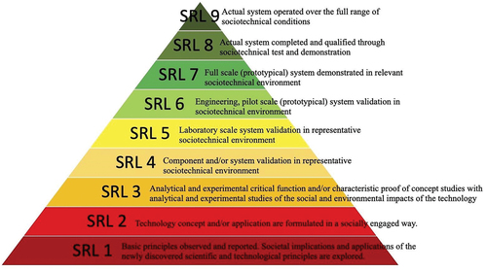

Figure 2: Trading volume across events.

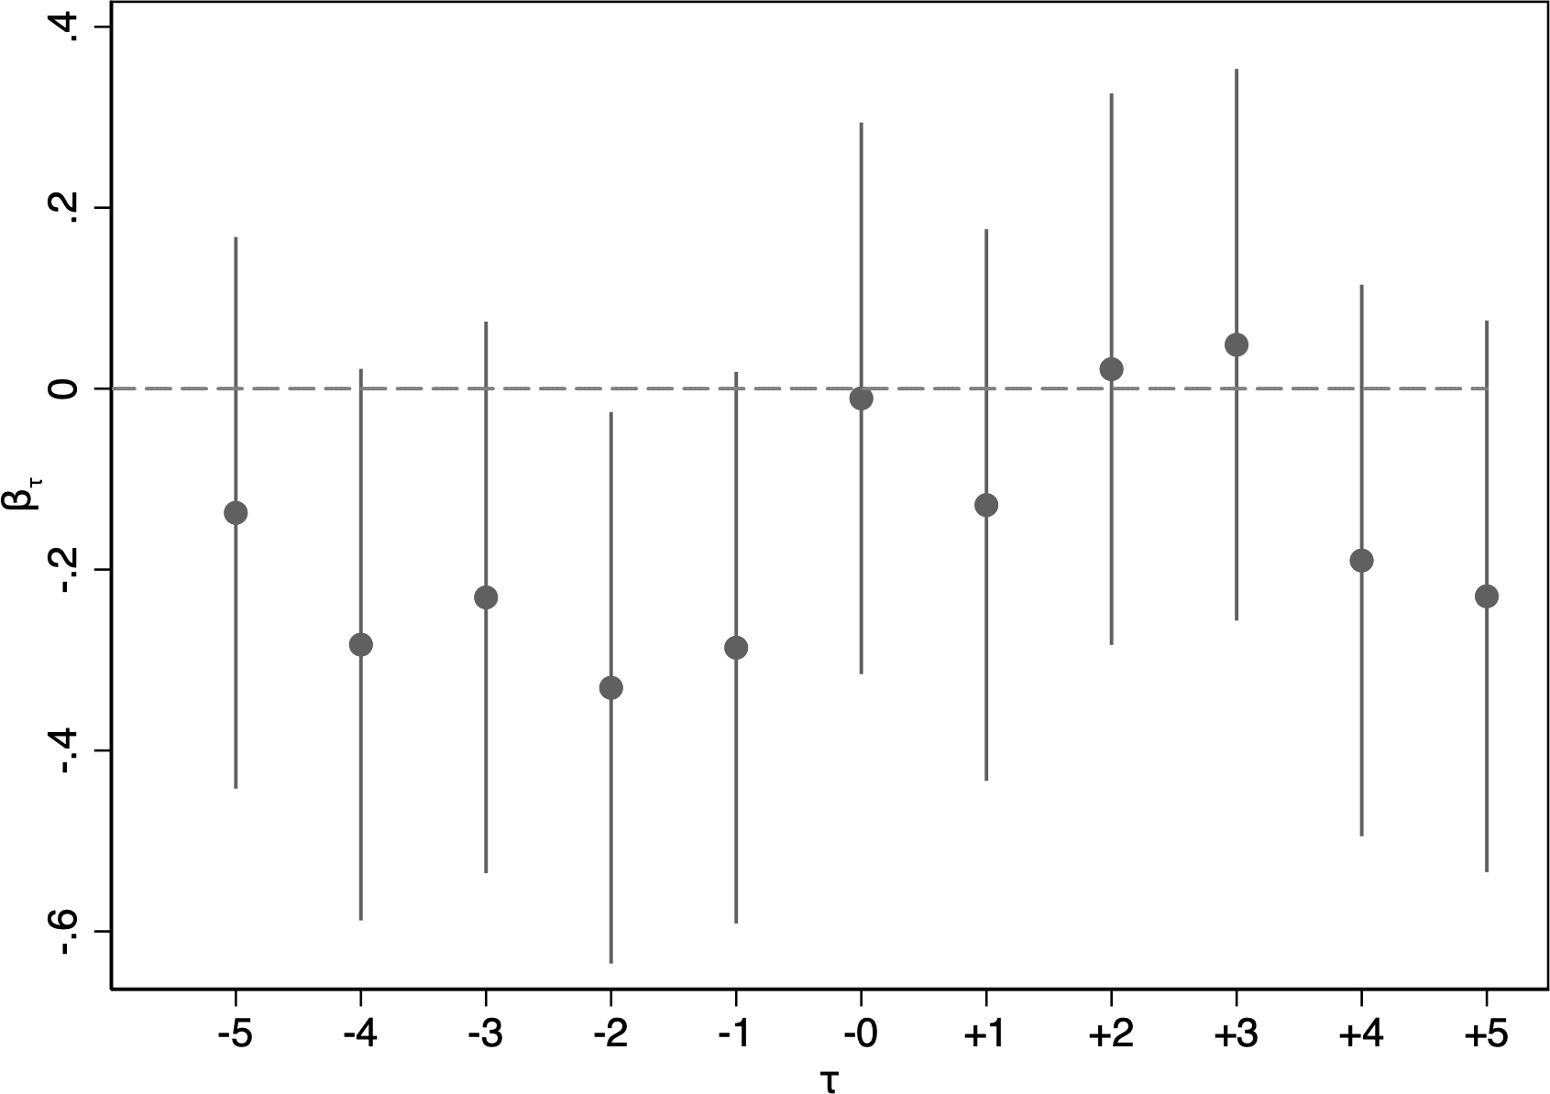

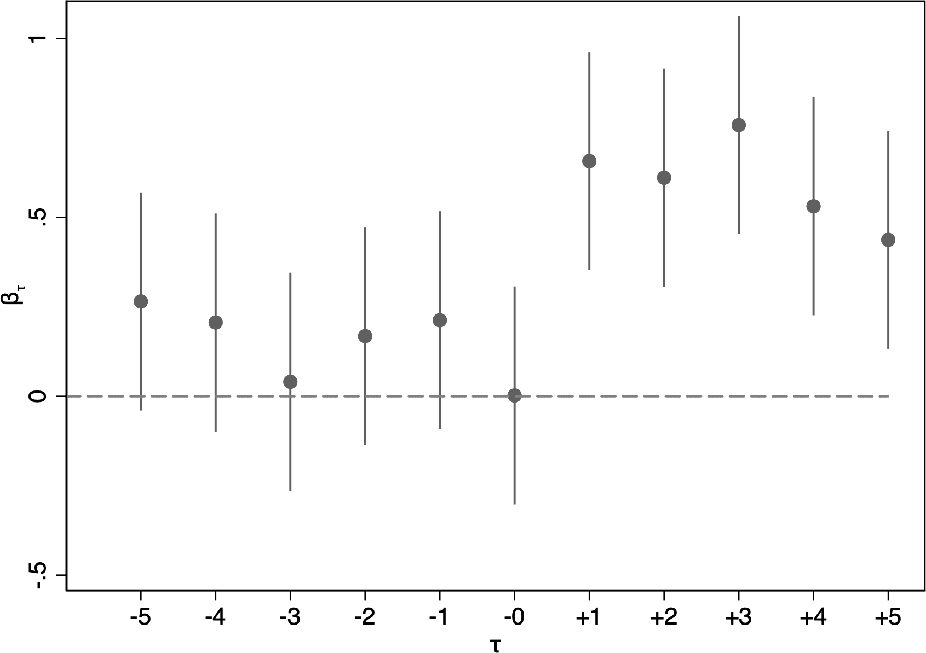
- March 11, 2011: Fukushima earthquake

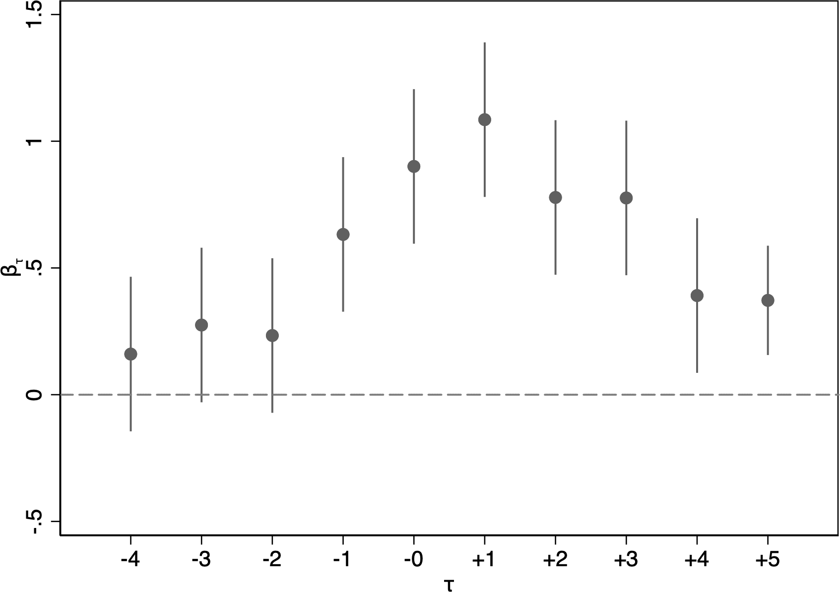
(c) August 6, 2011: Amendment of the German Atomic Energy Act

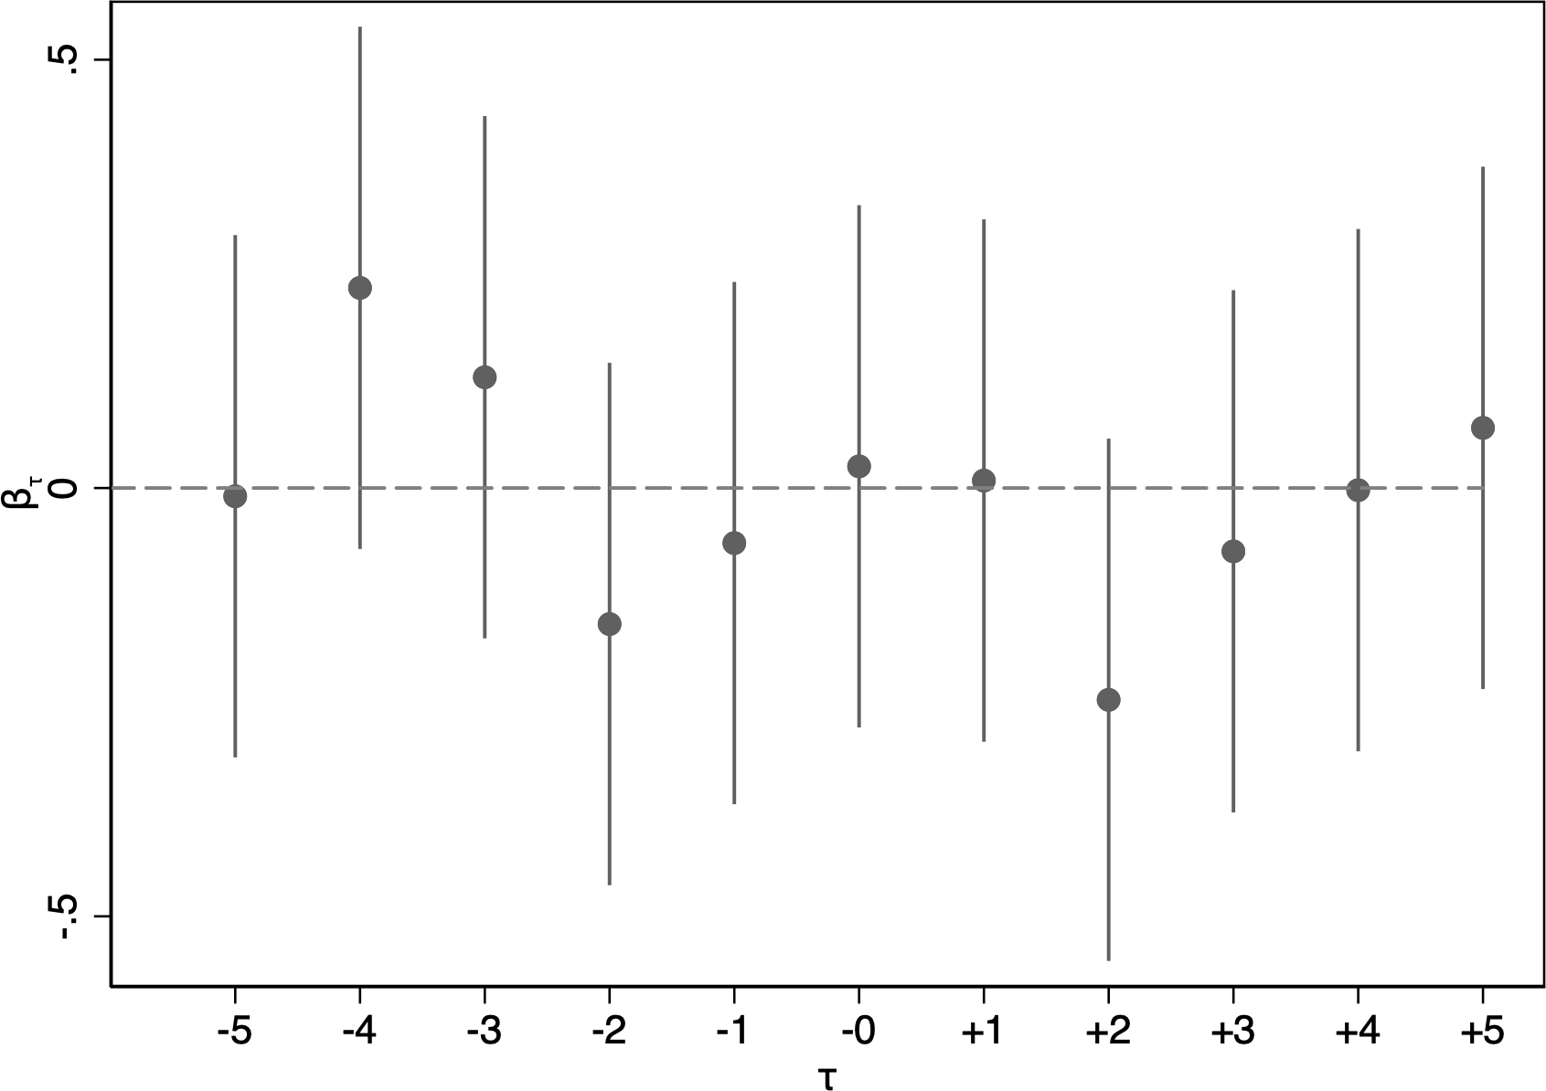
(e)April 19, 2012: Permanent shutdown of Fukushima Reactors
(b)July 12, 2011: U.S. NRC Task Force Report
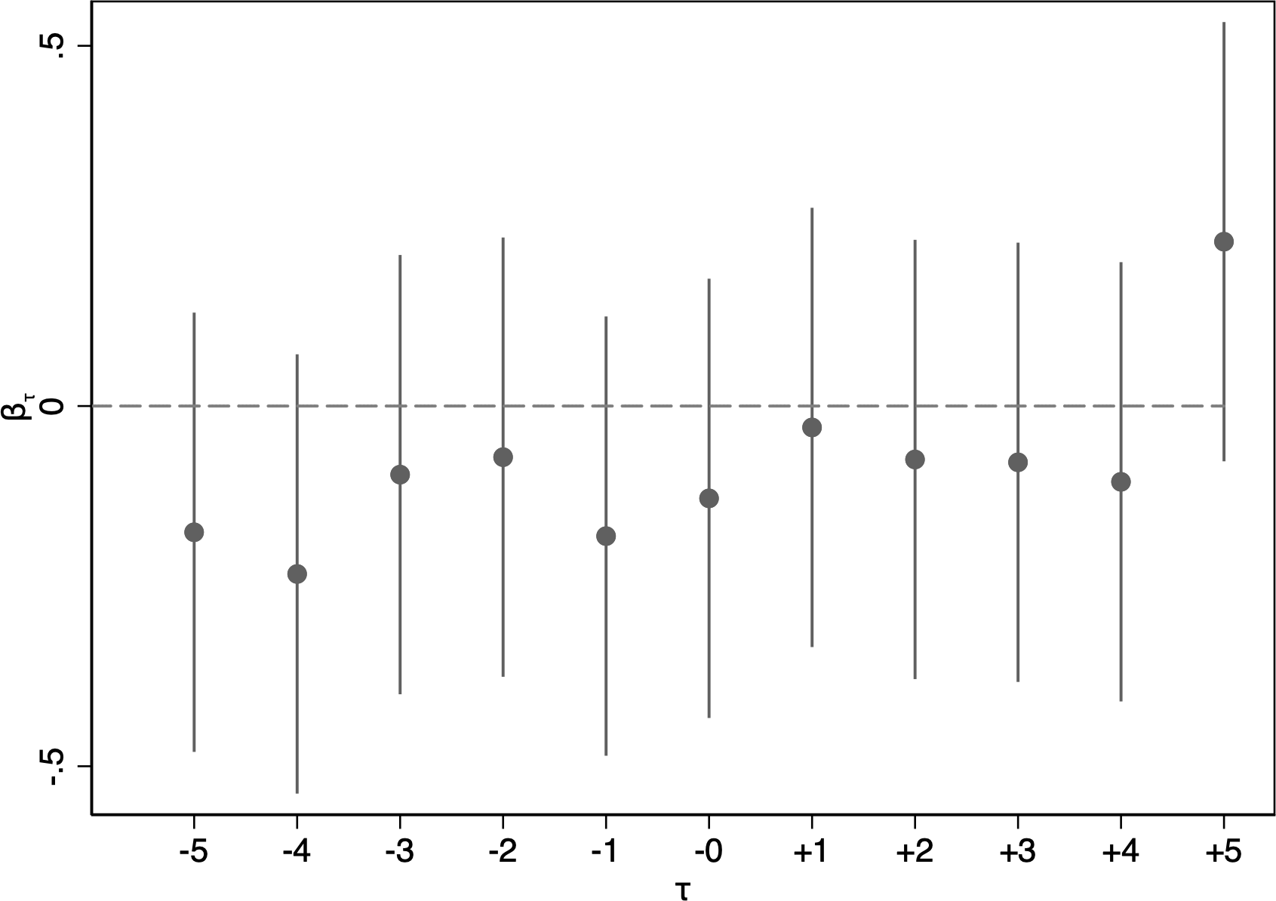

(d)March 9, 2012: NRC Mandates New Safety Measures

Figure 3. Stock prices across events.

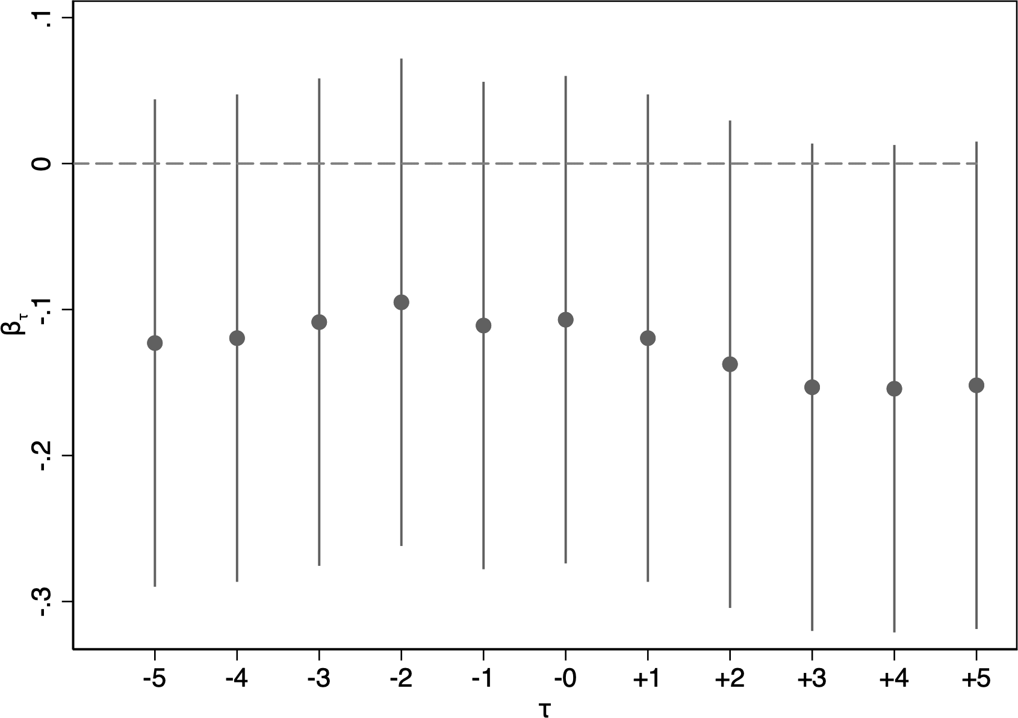
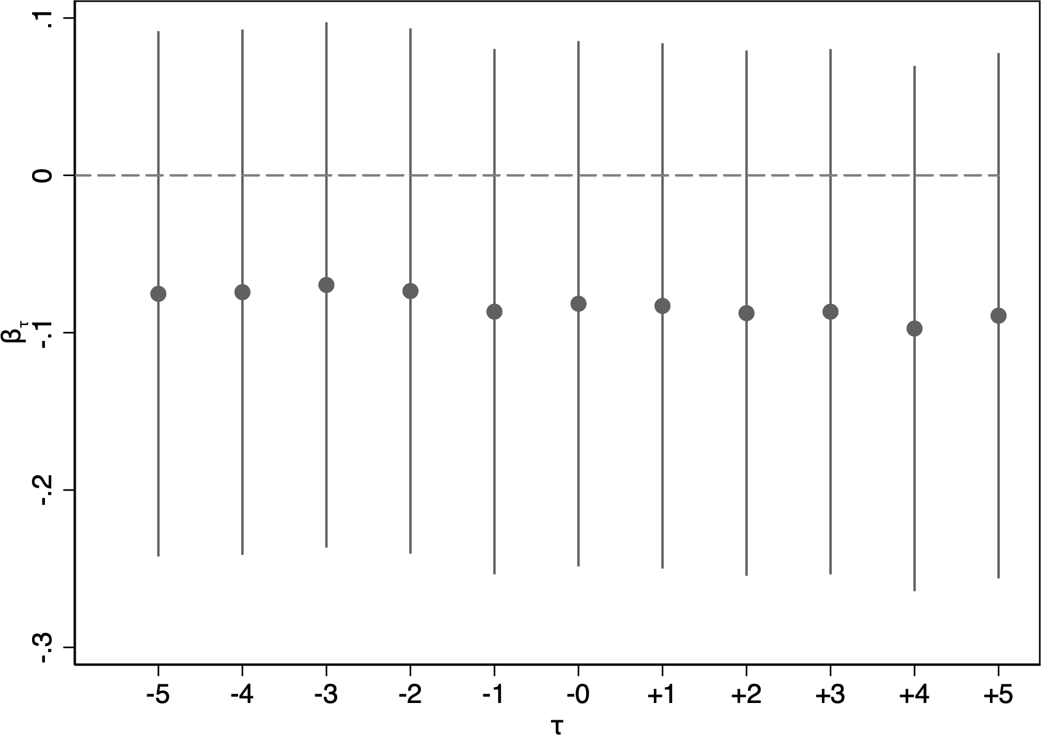

(a) March 11, 2011: Fukushima earthquake
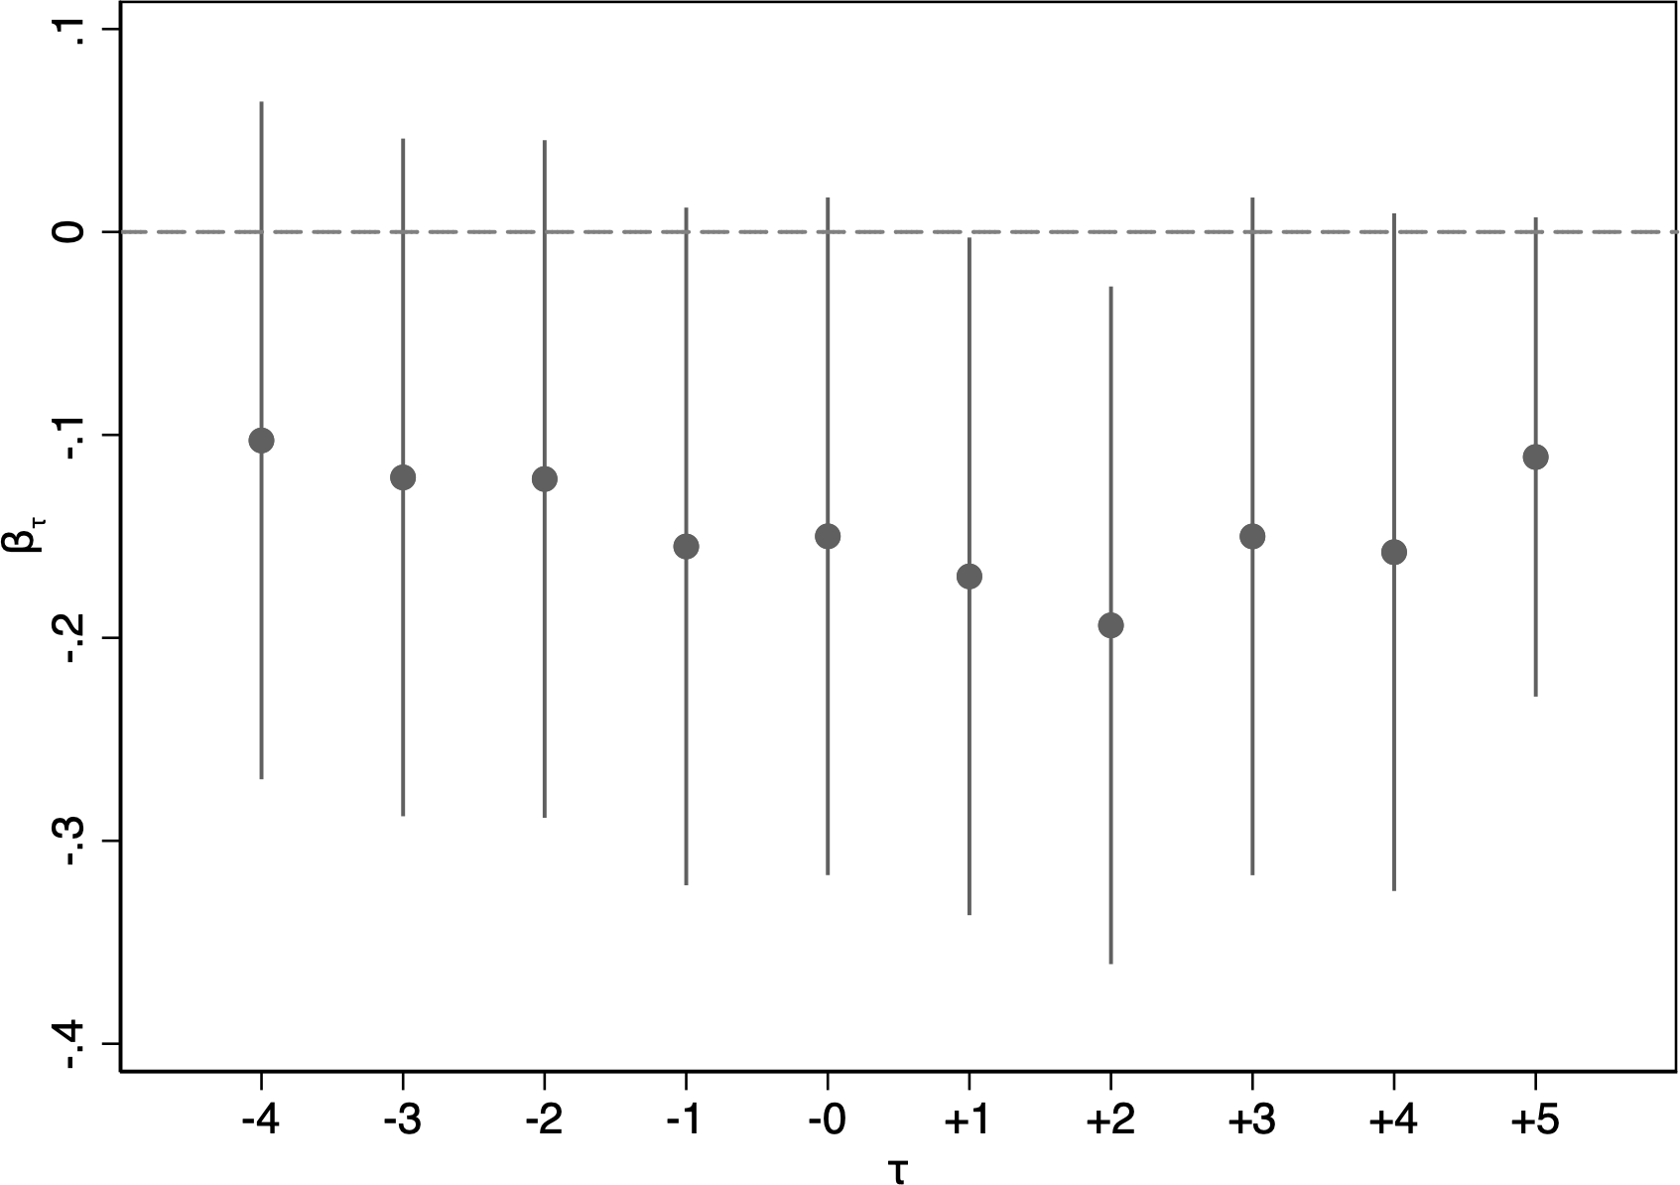
(c) August 6, 2011: Amendment of the German Atomic Energy Act

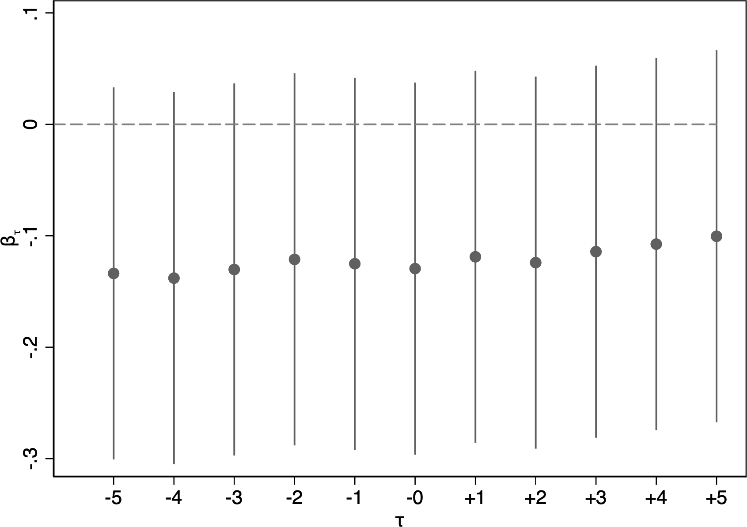
(e) April 19, 2012: Permanent Shutdown of Fukushima Reactors
(b) July 12, 2011: U.S. NRC Task Force Report
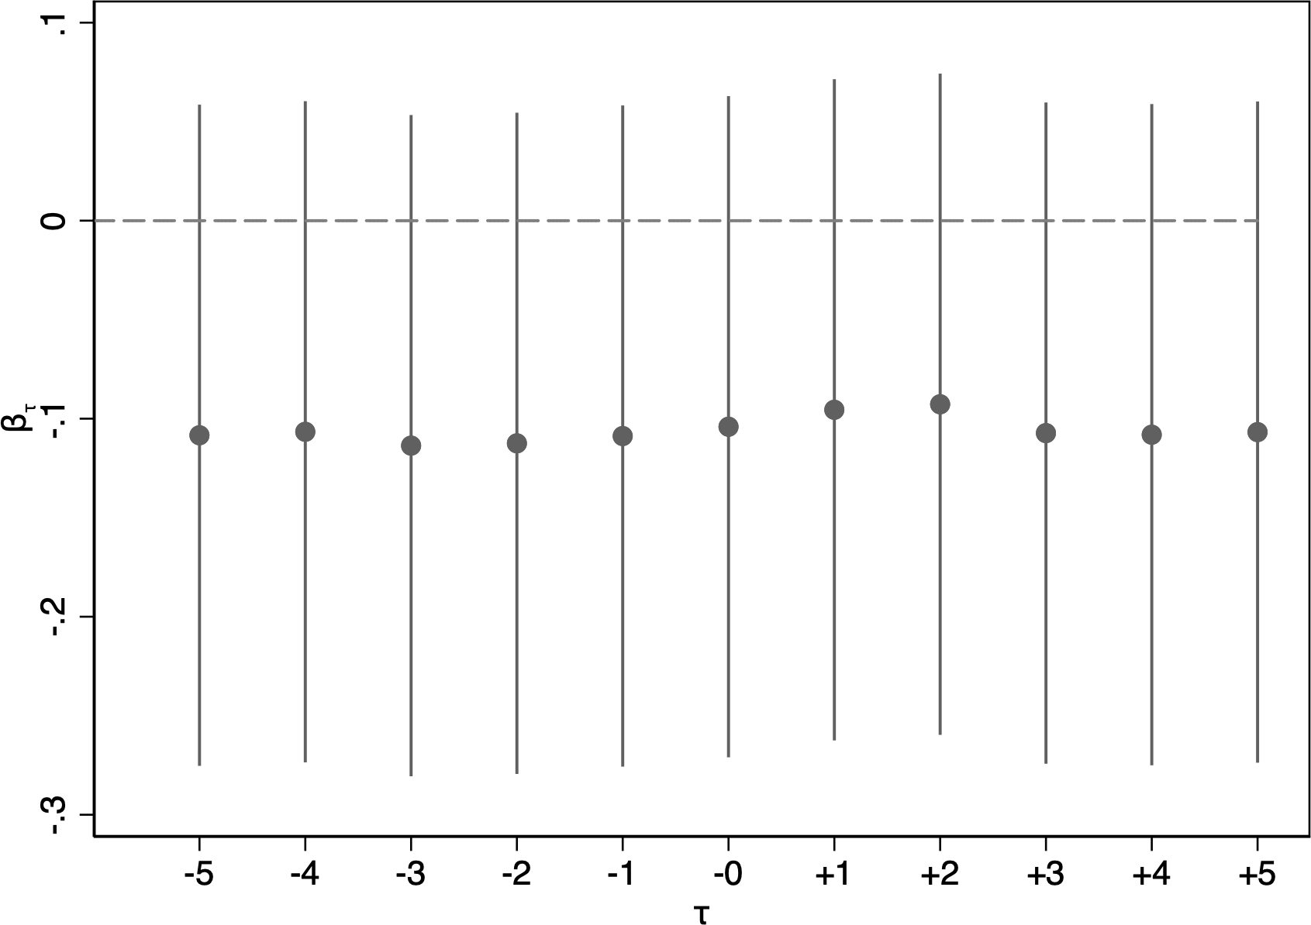
(d)March 9, 2012: NRC Mandates New Safety Measures

Table 1. Description of Empirical Variables included in the model.

U.S. Energy Information Administration Data

CO2_Emission_MillionMetricTon | Measures the total carbon dioxide emissions in million metric tons, providing insight into the environmental impact of energy consumption and guiding emission reduction policies.
Electricity Net Imports (Trillion Btu) | Represents the amount of electricity imported, measured in trillion British thermal units (Btu), indicating dependency on external sources and affecting energy security and trade policies.
End-Use Energy Consumed by the End-Use Sectors (Trillion Btu | Captures the total energy consumed by various end-use sectors, in trillion Btu, which helps assess energy demand patterns and sector-specific efficiency
Energy Balance (Million Dollars) | Reflects the financial balance of energy transactions, measured in million dollars, offering insight into the economic trade-offs and policy impacts related to energy imports and exports.
Fossil Fuel Net Imports (Trillion Btu) | Shows the net amount of fossil fuels imported, in trillion Btu, indicating reliance on foreign fossil fuels and influencing energy independence and trade policies.
Nuclear Electric Power Consumed by the Electric Power Sector (Trillion Btu) | Details the consumption of nuclear-generated electricity by the power sector, measured in trillion Btu, highlighting the role of nuclear energy in electricity generation.
Nuclear Generating Units, Net Summer Capacity (Million Kilowatts) | Represents the total summer net capacity of nuclear-generating units in million kilowatts, essential for evaluating nuclear power generation capacity and infrastructure
Nuclear Generating Units, Total Operable Units (Number) | Indicates the total number of operable nuclear generating units, providing a count of available nuclear reactors and supporting infrastructure assessments.
Primary Energy Stock Change and Other (Trillion Btu) | Covers changes in primary energy stock and other related factors, measured in trillion Btu, reflecting fluctuations in energy reserves and inventory management
Renewable Net Imports (Trillion Btu) | Shows the net imports of renewable energy, in trillion Btu, highlighting the role of renewables in meeting energy needs and influencing energy policy and sustainability efforts
Total Fossil Fuels Consumption (Trillion Btu) | Measures the total consumption of fossil fuels, in trillion Btu, providing insights into fossil fuel use patterns and their impact on energy policy and environmental concerns.
Total Fossil Fuels Non-Combustion Consumption (Trillion Btu) | Represents fossil fuel consumption not related to combustion processes, measured in trillion Btu, affecting resource management and industrial applications.
Total Fossil Fuels Production (Trillion Btu) | Captures the total production of fossil fuels, in trillion Btu, crucial for assessing domestic energy supply and its implications for energy policy and market stability.
Total Primary Energy Imports (Trillion Btu) | Reflects the total amount of primary energy imported, in trillion Btu
Total Renewable Energy Production (Trillion Btu) | Measures the total production of renewable energy, in trillion Btu, supporting the evaluation of renewable energy contributions to the energy mix and sustainability goals.
Average Fossil Fuel Price (Dollars per Million Btu) | Shows the average price of fossil fuels, in dollars per million Btu, influencing energy costs, market trends, and policy decisions related to fuel pricing and subsidies.
Electricity End Use, Total (Trillion Btu) | Represents the total energy used for electricity consumption, in trillion Btu, highlighting demand patterns and efficiency in the electricity sector.
Electricity Net Generation From Nuclear Electric Power, All Sectors (Trillion Btu) | Measures the net generation of electricity from nuclear power across all sectors, in trillion Btu, indicating the contribution of nuclear energy to the overall electricity supply
Electricity Net Generation from Fossil Fuels (Trillion Btu) | Indicates the net generation of electricity from fossil fuels, measured in trillion Btu, reflecting the reliance on fossil fuels for electricity and its impact on energy policy.
Electricity Net Generation from Renewable sources (Trillion Btu) | Represents the net generation of electricity from renewable sources, in trillion Btu, showcasing the role of renewables in electricity generation and progress toward sustainability targets.
Clean_energy_sentiment | Captures public sentiment regarding clean energy, providing insights into societal attitudes towards renewable energy and influencing policy and market trends.
Nuclear_Energy_acceptance | Measures public acceptance of nuclear energy, reflecting societal views on nuclear power and its implications for energy policy and infrastructure development.
CRSP Data

Return | Stock return for the quarter computed using monthly data
Volume | Trading volume for the quarter computed using monthly data
Market Capitalization | Computed using stock prices and number of shares outstanding

Table 2. Mapping of Theoretical and Empirical Variables.

 | Theoretical variables | Notation | Empirical variables |  | Specification
 | Nuclear investment measures | I | Market Capitalization |  | Dependent variable
Market Return

Trading Volume

 | Risk perception  Social Readiness Level (SRL) | $θ_{L}$ γ | Nuclear Sentiment Society Readiness Level |  | Independent variable
 | Fossil fuel price  Fossil fuel consumption | $$p_{f}$$  $$e_{f}$$ | Fossil fuel price  Fossil Fuel Consumption (combustion & Non-combustion) Fossil Fuel Production
 | Renewable energy consumption | $$e_{c}$$ | Renewable Energy Production  Electricity End Use
 | Operating cost | $$δ$$ | Nuclear Production Capacity (Net Summer Capacity)
 |  |  | Nuclear Production Capacity (Operating Units)
 | N/A |  | CO2 Emissions |  | Controls
 |  |  | Electricity Net Imports
 |  |  | Fossil Fuel Net Imports
 |  |  | Electricity Production from Nuclear
 |  |  | Electricity Production from Fossil Fuels
 |  |  | Electricity Production from Fossil Fuels
 |  |  | Firm-fixed effects

Table 3. Summary Statistics.

Control variables and measure of societal readiness
 | count | mean | min | 25% | 50% | 75% | max | std
CO2_Emission_MillionMetricTon | 615 | 431.43 | 305.60 | 393.35 | 428.33 | 464.71 | 560.78 | 49.26
Electricity Net Imports (Trillion Btu) | 615 | 8.83 | -4.77 | 5.32 | 8.90 | 11.90 | 24.22 | 4.96
End-Use Energy Consumed by the End-Use Sectors (Trillion Btu) | 615 | 5607.57 | 4161.38 | 5127.59 | 5667.17 | 6015.75 | 7396.83 | 670.80
Energy Balance (Million Dollars) | 615 | -7781.92 | -49893.00 | -10459.00 | -4336.20 | -3012.20 | 8529.00 | 9044.09
Fossil Fuel Net Imports (Trillion Btu) | 615 | 1204.90 | -923.12 | 816.49 | 1176.29 | 1730.99 | 2720.57 | 776.61
Nuclear Electric Power Consumed by the Electric Power Sector (Trillion Btu) | 615 | 523.79 | 62.11 | 336.23 | 600.76 | 681.99 | 780.46 | 201.81
Nuclear Generating Units, Net Summer Capacity (Million Kilowatts) | 615 | 85.62 | 14.53 | 78.94 | 98.53 | 99.63 | 102.21 | 23.27
Nuclear Generating Units, Total Operable Units (Number) | 615 | 94.09 | 42.00 | 87.00 | 104.00 | 104.00 | 112.00 | 16.25
Primary Energy Stock Change and Other (Trillion Btu) | 615 | 29.88 | -953.83 | -331.93 | -79.21 | 322.32 | 1551.35 | 476.55
Renewable Net Imports (Trillion Btu) | 615 | -2.47 | -22.82 | -2.12 | 0.13 | 0.13 | 10.63 | 5.59
Total Fossil Fuels Consumption (Trillion Btu) | 615 | 6326.29 | 4783.91 | 5816.23 | 6340.76 | 6789.75 | 8096.32 | 703.69
Total Fossil Fuels Non-Combustion Consumption (Trillion Btu) | 615 | 828.46 | 449.36 | 746.95 | 829.56 | 914.98 | 1170.22 | 129.65
Total Fossil Fuels Production (Trillion Btu) | 615 | 5091.29 | 3676.07 | 4689.52 | 4846.47 | 5149.14 | 7418.70 | 694.80
Total Primary Energy Imports (Trillion Btu) | 615 | 1871.71 | 710.56 | 1460.02 | 1841.00 | 2267.85 | 3149.64 | 554.11
Total Renewable Energy Production (Trillion Btu) | 615 | 398.79 | 185.30 | 310.37 | 346.95 | 508.07 | 769.47 | 140.59
Average Fossil Fuel Price (Dollars per Million Btu | 615 | 4.32 | 0.49 | 2.08 | 3.30 | 6.29 | 14.29 | 2.92
Electricity End Use, Total (Trillion Btu) | 615 | 891.84 | 448.22 | 671.68 | 945.99 | 1068.33 | 1379.65 | 236.39
Electricity Net Generation From Nuclear Electric Power, All Sectors (Trillion Btu) | 615 | 170.02 | 19.44 | 107.92 | 195.76 | 222.33 | 254.71 | 67.01
Electricity Net Generation from Fossil Fuels (Trillion Btu) | 615 | 653.94 | 361.80 | 527.65 | 649.95 | 758.90 | 1091.17 | 157.79
Electricity Net Generation from Renewable sources (Trillion Btu) | 615 | 119.49 | 53.52 | 86.42 | 102.47 | 132.56 | 304.12 | 50.51
Clean_energy_sentiment | 347 | 0.05 | -0.01 | 0.02 | 0.04 | 0.06 | 0.18 | 0.03
Nuclear_Energy_acceptance | 408 | 0.03 | -0.04 | 0.01 | 0.02 | 0.04 | 0.14 | 0.02
SRL | 615 | 7.55 | 3 | 8 | 9 | 9 | 9 | 2.55
Brown Energy Companies Trading Data
 | count | mean | min | 25% | 50% | 75% | max | std
Volume | 15,366 | 194988.43 | 4.00 | 13113.75 | 64893.00 | 235573.25 | 11815106.00 | 363024.42
Return | 15,331 | 0.01 | -0.80 | -0.03 | 0.01 | 0.05 | 3.62 | 0.10
Shares | 15,366 | 169562.81 | 696.00 | 22932.00 | 89092.00 | 242635.00 | 2568985.00 | 215618.72
Price | 15,366 | 34.79 | 0.06 | 21.11 | 31.49 | 43.75 | 188.86 | 23.01
MarketCap | 15,366 | 6927835.82 | 452.34 | 515537.50 | 2648266.04 | 9029269.03 | 83871273.36 | 10249242.26
Nuclear Energy Companies Trading Data
 | count | mean | min | 25% | 50% | 75% | max | std
Volume | 3,666 | 452296.23 | 152.00 | 95917.50 | 250861.00 | 621024.00 | 11815106.00 | 615732.82
Return | 3,666 | 0.01 | -0.45 | -0.02 | 0.01 | 0.04 | 1.12 | 0.07
Shares | 3,666 | 365789.07 | 2933.00 | 163053.75 | 247396.00 | 499259.00 | 2568985.00 | 309150.65
Price | 3,666 | 44.22 | -0.63 | 29.04 | 39.25 | 53.36 | 140.02 | 22.82
MarketCap | 3,666 | 15956832.84 | -3676.25 | 5903393.13 | 10148164.91 | 21404033.63 | 86629035.48 | 14860947.12

Table 4.Timeline of significant events that followed Fukushima Accident.

Date | Event Description | SRL Scale | Country
March 11, 2011 | Shutdown of nuclear reactors for safety checks | SRL 6 | Japan
March 14, 2011 | Moratorium on oldest nuclear reactors | SRL 6 | Germany
June 30, 2011 | Legislation to phase out nuclear power by 2022 | SRL 5 or SRL 4 | Germany
July 12, 2011 | NRC’s conclusion on reactors’ continued operation | SRL 8 | USA
August 6, 2011 | The Atomic Energy Act to formalize the nuclear phase-out | SRL 3 | Germany
March 9, 2012 | New safety measures for all U.S. nuclear power plants | SRL 8 | USA
April 19, 2012 | Permanent shutdown decision of the Fukushima Daiichi reactors. | SRL 3 | Japan

Table 5. Market value of the energy firms and societal readiness for sustainable energy sources.

In this table we present the results of the regression model that highlights relationship between measures of societal acceptance of sustainable energy and market value of the energy firms in two categories – those involved in nuclear energy generation (nuclear) and those that are generate energy from traditional fossil fuels (brown). The societal readiness is measured by three indicators in different specifications. First, we look at the sentiment towards green energy in the public new data sources. Second, we look at the same indicator based on the news related to nuclear industry. Finally, we introduce the new emerging Societal Readiness Level framework. We introduce firm, year and quarter fixed effects and also use the following variables as controls: Nuclear Generating Units, Average Fossil Fuel Price (Dollars per Million Btu), CO2_Emission_Million (Metric Ton), Electricity Net Imports (Trillion Btu), Fossil Fuel Net Imports (Trillion Btu),Nuclear Generating Units, Total Fossil Fuels Consumption (Trillion Btu),Total Fossil Fuels Non-Combustion Consumption (Trillion Btu),Total Fossil Fuels Production (Trillion Btu),Total Renewable Energy Production (Trillion Btu), Electricity End Use, Electricity Net Generation, From Nuclear Electric Power, Electricity Net Generation from Fossil Fuels (Trillion Btu),Electricity Net Generation from Renewable sources (Trillion Btu).

 |  | Market Value of the Firms
 |  | Nuclear Energy |  |  |  |  |  | Brown Energy
Green Sentiment |  | -101,400,000 |  |  | ** |  |  | -20,310,000
 | No Obs |  | 1,260 |  |  |  |  |  | 5,600
 | Adj.R2 |  | 0.726 |  |  |  |  |  | 0.702
Nuclear Sentiment |  | -128,500,000 |  |  | *** |  |  | -21,660,000
 | No Obs |  | 1,260 |  |  |  |  |  | 5,600
 | Adj.R2 |  | 0.726 |  |  |  |  |  | 0.702
SRL |  | -1,853,000 |  |  | ** |  |  | 107,800
No Obs |  |  |  | 1,260 |  |  |  |  |  | 5,600
Adj.R2 |  |  |  | 0.726 |  |  |  |  |  | 0.702
Controls |  | YES |  |  |  |  |  | YES
Firm FE |  | YES |  |  |  |  |  | YES
Year FE |  | YES |  |  |  |  |  | YES
Quarter FE |  | YES |  |  |  |  |  | YES

Table 6. Returns of the energy firms and societal readiness for sustainable energy sources.

In this table we present the results of the regression model that highlights relationship between measures of societal acceptance of sustainable energy and equity returns of the energy firms in two categories – those involved in nuclear energy generation (nuclear) and those that are generate energy from traditional fossil fuels (brown). The societal readiness is measured by three indicators in different specifications. First, we look at the sentiment towards green energy in the public new data sources. Second, we look at the same indicator based on the news related to nuclear industry. Finally, we introduce the new emerging Societal Readiness Level framework. We introduce firm, year and quarter fixed effects and also use the following variables as controls: Nuclear Generating Units, Average Fossil Fuel Price (Dollars per Million Btu), CO2_Emission_Million (Metric Ton), Electricity Net Imports (Trillion Btu), Fossil Fuel Net Imports (Trillion Btu),Nuclear Generating Units, Total Fossil Fuels Consumption (Trillion Btu),Total Fossil Fuels Non-Combustion Consumption (Trillion Btu),Total Fossil Fuels Production (Trillion Btu),Total Renewable Energy Production (Trillion Btu), Electricity End Use, Electricity Net Generation, From Nuclear Electric Power, Electricity Net Generation from Fossil Fuels (Trillion Btu),Electricity Net Generation from Renewable sources (Trillion Btu).

 |  | Equity Returns of the Firms
 |  | Nuclear Energy |  |  |  |  |  | Brown Energy
Green Sentiment |  | -0.1962 |  |  |  |  |  | -0.3078 |  |  | **
 | No Obs |  | 1,260 |  |  |  |  |  | 5,600
 | Adj.R2 |  | 0.02 |  |  |  |  |  | 0.008
Nuclear Sentiment |  | -0.9206 |  |  | *** |  |  | -0.5395 |  |  | ***
 | No Obs |  | 1,260 |  |  |  |  |  | 5,600
 | Adj.R2 |  | 0.029 |  |  |  |  |  | 0.009
SRL |  | -0.0102 |  |  | *** |  |  | -0.0033
No Obs |  |  |  | 1,260 |  |  |  |  |  | 5,600
Adj.R2 |  |  |  | 0.025 |  |  |  |  |  | 0.008
Controls |  | YES |  |  |  |  |  | YES
Firm FE |  | YES |  |  |  |  |  | YES
Year FE |  | YES |  |  |  |  |  | YES
Quarter FE |  | YES |  |  |  |  |  | YES

Verma and Allen (2024)

